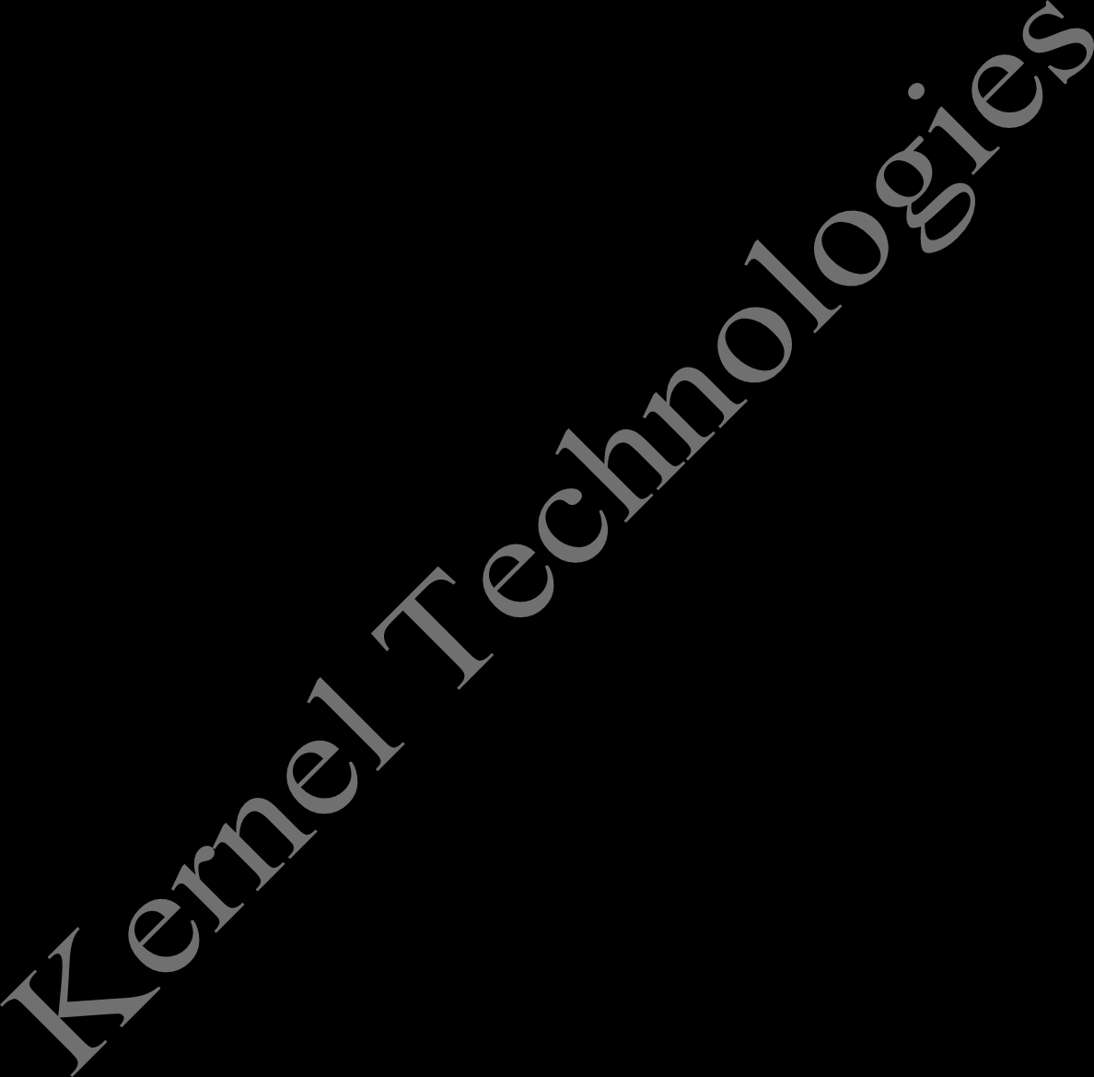

**ARCHITECTURE OF UNIX**

The architecture of UNIX can be divided into three levels of functionality, as shown in Figure . The lowest level is the *kernel* , which schedules tasks , manages resources, and controls security. The next level is the *shell,* which acts as the user interface, interpreting user commands and starting applications. The highest level is *utilities,* which provides utility functions. In other words it is the USER level, as user is the one who operates those utilities.

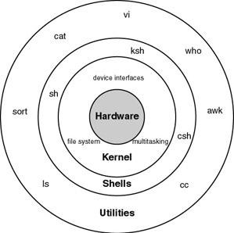

## FILESYSTEM HIERARCHY SYSTEM

**Linux uses single rooted, inverted tree like file system hierarchy**

**/** This is top level directory

It is parent directory for all other directories It is called as ROOT directory

It is represented by forward slash (/) C:\ of windows

**/root** it is home directory for root user (super user) It provides working environment for root user C:\Documents and Settings\Administrator

**/home** it is home directory for other users

It provide working environment for other users (other than root) c:\Documents and Settings\username

**/boot** it contains bootable files for Linux

Like vmlinuz (kernel). ntoskrnl

Initrd (INITial Ram Disk)and

GRUB (GRand Unified Boot loader). boot.ini, ntldr

**/etc** it contains all configuration files

Like /etc/passwd..... User info

/etc/resolv.conf... Preferred DNS

/etc/dhcpd.conf DHCP server

C:\windows\system32\dirvers\

**/usr** by default soft wares are installed in /usr directory (UNIX Sharable Resources)

c:\program files

**/opt** It is optional directory for /usr It contains third party softwares c:\program files

**/bin** it contains commands used by all users (Binary files)

**/sbin** it contains commands used by only Super User (root) (Super user's binary files)

**/dev** it contains device files

Like /dev/hda ... for hard disk

/dev/cd rom ... for cd rom

Similar to device manager of windows

**/proc** it contain process files

Its contents are not permanent, they keep changing It is also called as Virtual Directory

Its file contain useful information used by OS

like /proc/meminfo ... information of RAM/SWAP

/proc/cpuinfo ... information of CPU

**/var** it is containing variable data like mails, log files

**/mnt** it is default mount point for any partition It is empty by default

**/media** it contains all of removable media like CD-ROM, pen drive

**/lib** it contains library files which are used by OS It is similar to dll files of windows

Library files in Linux are SO (shared object) files